Assignment 10 Report

1. 16 units LSTM encoder-decoder
   * Loss: 0.0397
   * Accuracy: 0.99258
   * 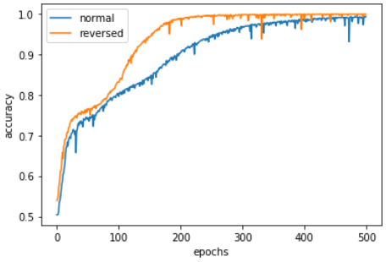
2. Stacked x3 16 units LSTM encoder-decoder
   * Loss: 0.34353
   * Accuracy: 0.86758
   * 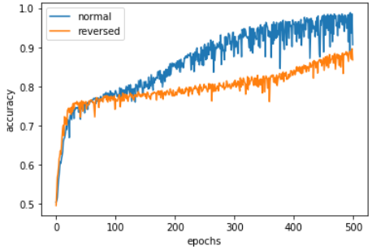
3. (The best) 256 units LSTM encoder-decoder
   * Loss: 0.00061
   * Accuracy: 0.99975
   * 